Step 1  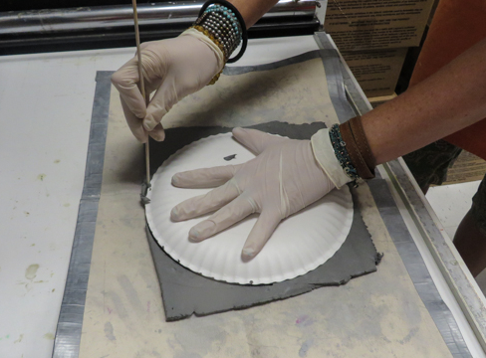  Write your name in center of the circle.  Flip circle over to show the top side. | STEP 2  SMOOTH THE EDGES WITH WATER  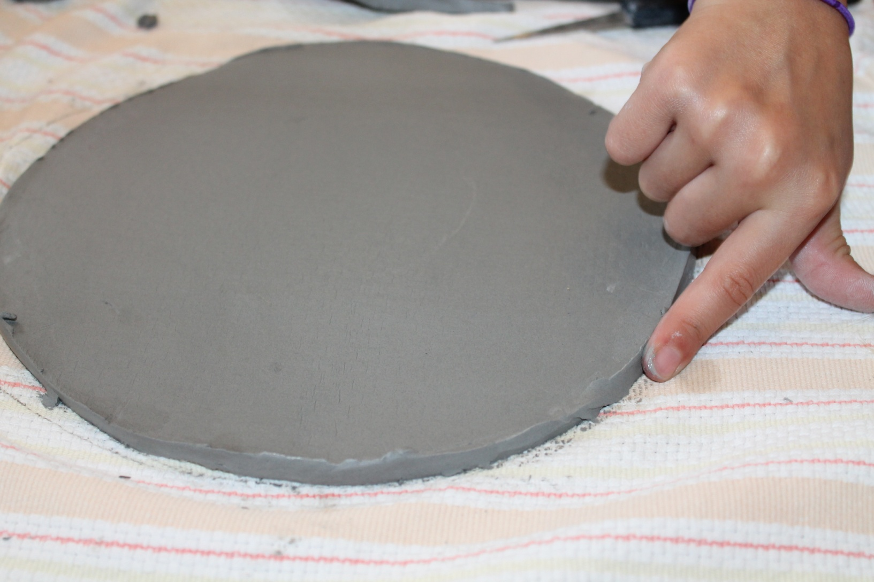
STEP 3  Make impressions on the bottom  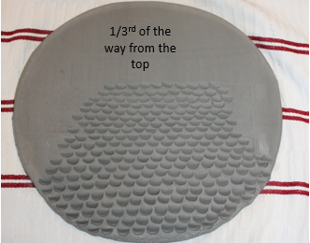 | STEP 4  Fold over both sides for wings  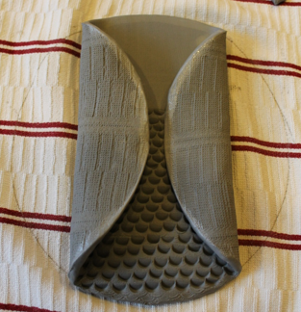
STEP 5  Make impressions on wings  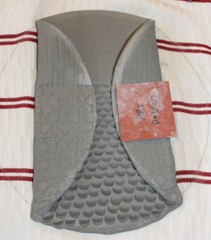  1/3rd of the way from the top | STEP 6  Fold over top with pencil in place until finished  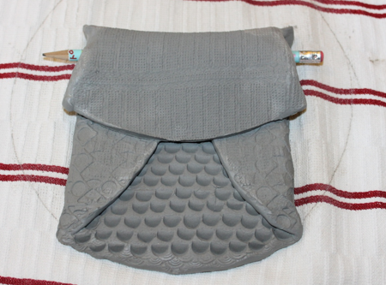

STEP 7  Pinch clay to shape ears  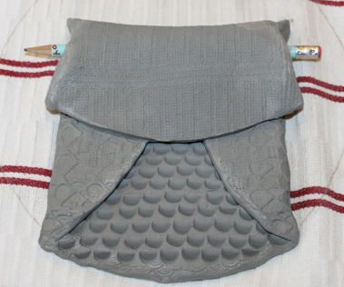 | STEP 8  Cut out eyes  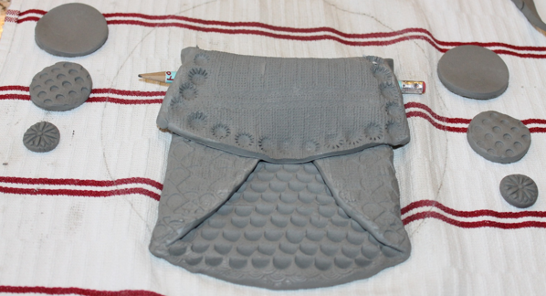
STEP 9  Score and Slip to attach parts  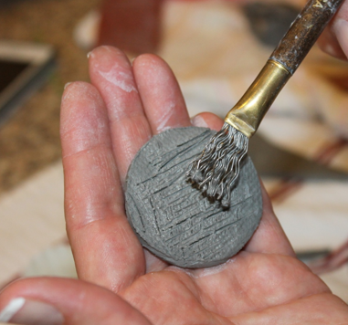 | STEP 10  Cut out Triangle for Beak  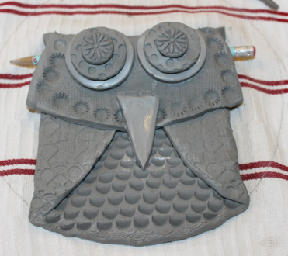
STEP 11  Cut out feet and attach  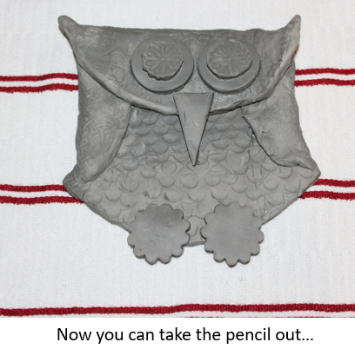 | STEP 12  Put owl on paper plate to dry for 2 weeks

